Analysis of ““theLook” eCommerce” dataset

Report by Andrius Tunaitis

2023

# Executive summary

This report analyses the sales and profit results of “theLook” eCommerce company. Both sales and profit grew by 101 % in 2022 when compared to 2021. Profit margin remained almost stable as it grew by just 0.2 % in 2022 compared to 2021.

Moreover RFM (recency, frequency, monetary) analysis is carried out in order to separate our user segments. Most valuable and perspective segments are identified and action plans for those specific user groups are introduced. More specifically, we have a strong “champion” and weak “loyal” segment while the “at risk” segment should be given much attention to reactivate it.

Finally, user journey is researched by analyzing the customer funnel. The purchase funnel has been improving through the years. The percentages of the funnel seem to be quite uniform for different traffic sources and browsers.

# Introduction

“theLook” is a fictitious eCommerce clothing site developed by the Looker team. The dataset contains information about customers, products, orders, logistics, web events and digital marketing campaigns. The contents of this dataset are synthetic, and are provided to industry practitioners for the purpose of product discovery, testing, and evaluation.

This dataset is comprised of seven tables: distribution centers, events, inventory items, order items, orders, products and users. The data starts at the beginning of 2019 and is being updated until today. Tables contain data about location of distribution centers, user details, information about orders, inventory descriptions and a lot more specific information.

# Dashboard

In order to explore the dataset more easily, first of all a [dashboard](https://lookerstudio.google.com/s/txf2lEByEGw) was developed. This dashboard consists of four pages (Monetization, distribution centers, purchase funnel and RFM).

Monetization part consists KPIs (Total sales, profit, profit margin, average order value and number of orders). This page also has monthly profit, sales and orders graphs. There is also country table, geochart and categories treemap. The monetization page can be filtered by date, department, category and user’s age.

The distribution centers page was developed in order to explore data and search for insights for different distribution centers. There are 10 distribution centers and all of them are located in USA. This page has a distribution center table, geochart, units sold timeline chart, units sold distribution chart, days stayed at center, units at center and units sold per center graphs.

The third page in the dashboard is for funnel analysis. It is possible to filter purchase funnel by date, traffic source, browser and state selected in map.

The last page in the dashboard is the RFM analysis. There we can see the bubble graph with different segments and a table with recency, frequency and monetary values.

# Sales analysis

The dataset consists of such sales information as cost of a product and its retail price. Having these parameters, it is possible to calculate and analyze revenue, profit, profit margin etc. The comparison of the results for the year 2022 vs 2021 can be seen in table 1.

Table Monthly sales results for year 2022 vs. 2021.



Overall, we can see that sales and profit in 2022 grew by 101 % and profit margin increased by 0.2 %. When looking at the numbers monthly, every month sales and profit in 2022 increased compared to 2021.

The smallest growth of sales and profit was in 2022 Q1 and July. The smallest growth for sales and profit (81 %) is still very high compared to US ecommerce sales growth (7.4 %)[1]. December was the best month for 2022 and 2021 sales, profit, sales growth and profit growth.

The biggest growth of sales and profit was in 2022 Q4 and August. Both sales and profit grew by 127 % in December. This shows that “theLook” business is growing very fast as sales and profit more than doubled in a year.

A different story is seen when looking at the profit margin. There were four months (April, July, September and November) when profit margin was smaller in 2022 compared to 2021. Overall, in 2022 we saw a small increase in profit margin as it grew by 0.2 % to 51.9 %. Even though the profit margin is not growing it still looks pretty healthy well above the average in ecommerce (41.54%)[2].

All in all, it can be said that “theLook” business is performing well in regard to sales and profit. It has a high growth rate of sales and profit and a healthy profit margin value.

# RFM analysis

In order to analyze the results of the company on a customer level RFM analysis was carried out. Customers were divided into 7 categories: champion, loyal, promising, at risk, about to sleep, hibernating, lost. The results can be seen in table 2.

Table RFM segments. 2023 04 04

It can be seen that a large proportion of users belong to the “at risk”, “hibernating” and “about to sleep” segments. The most important of these groups is “at risk” as it has a high monetary value. The average order value of this segment is 176 $ which is second, the biggest value (274 $) being “champion. We need to figure out ways to convert these users to “loyal” or even “champion”.

There are a lot of different ways to engage with these customers. You can have special offers, rewards systems, use upselling techniques, recommend specific products, offer discounts, send e-mail offers etc. A list of specific segment tailored actionable tips can be seen in table 3.

Table Actionable tips for each customer segment.

|  |  |
| --- | --- |
| Segment | Tip |
| Champion | Introduce new products for them, include to a rewards system. |
| Loyal | Upsell, include to a rewards system. |
| Promising | Introduce to a rewards system. |
| At risk | Recommend on previous purchases, offer discounts, limited time offers. |
| About to sleep | Recommend popular products, offer discounts. |
| Hibernating | Offer discounts. |
| Lost | Send e-mails to reach out. |

# Funnel analysis

“theLook” dataset has “events” table which holds information about various actions taken by the users. There are 6 different event types: home, department, product, cart, purchase and cancel. Some of the user sessions start at the home , some at department and some at product step. In order to have a more logical, narrowing purchase funnel It was decided to use three steps for purchase funnel: product, cart and purchase.

Throughout the year the purchase funnel has been improving (figure 1). In the first year, 2019 only 4 % of those users who were at the “product” step continued and purchased. In 2020 that percentage went up to 14 %. It improved to 25 % and 42 % for 2021 and 2022 respectively. For 2023 this percentage is incredibly high at 65 %.

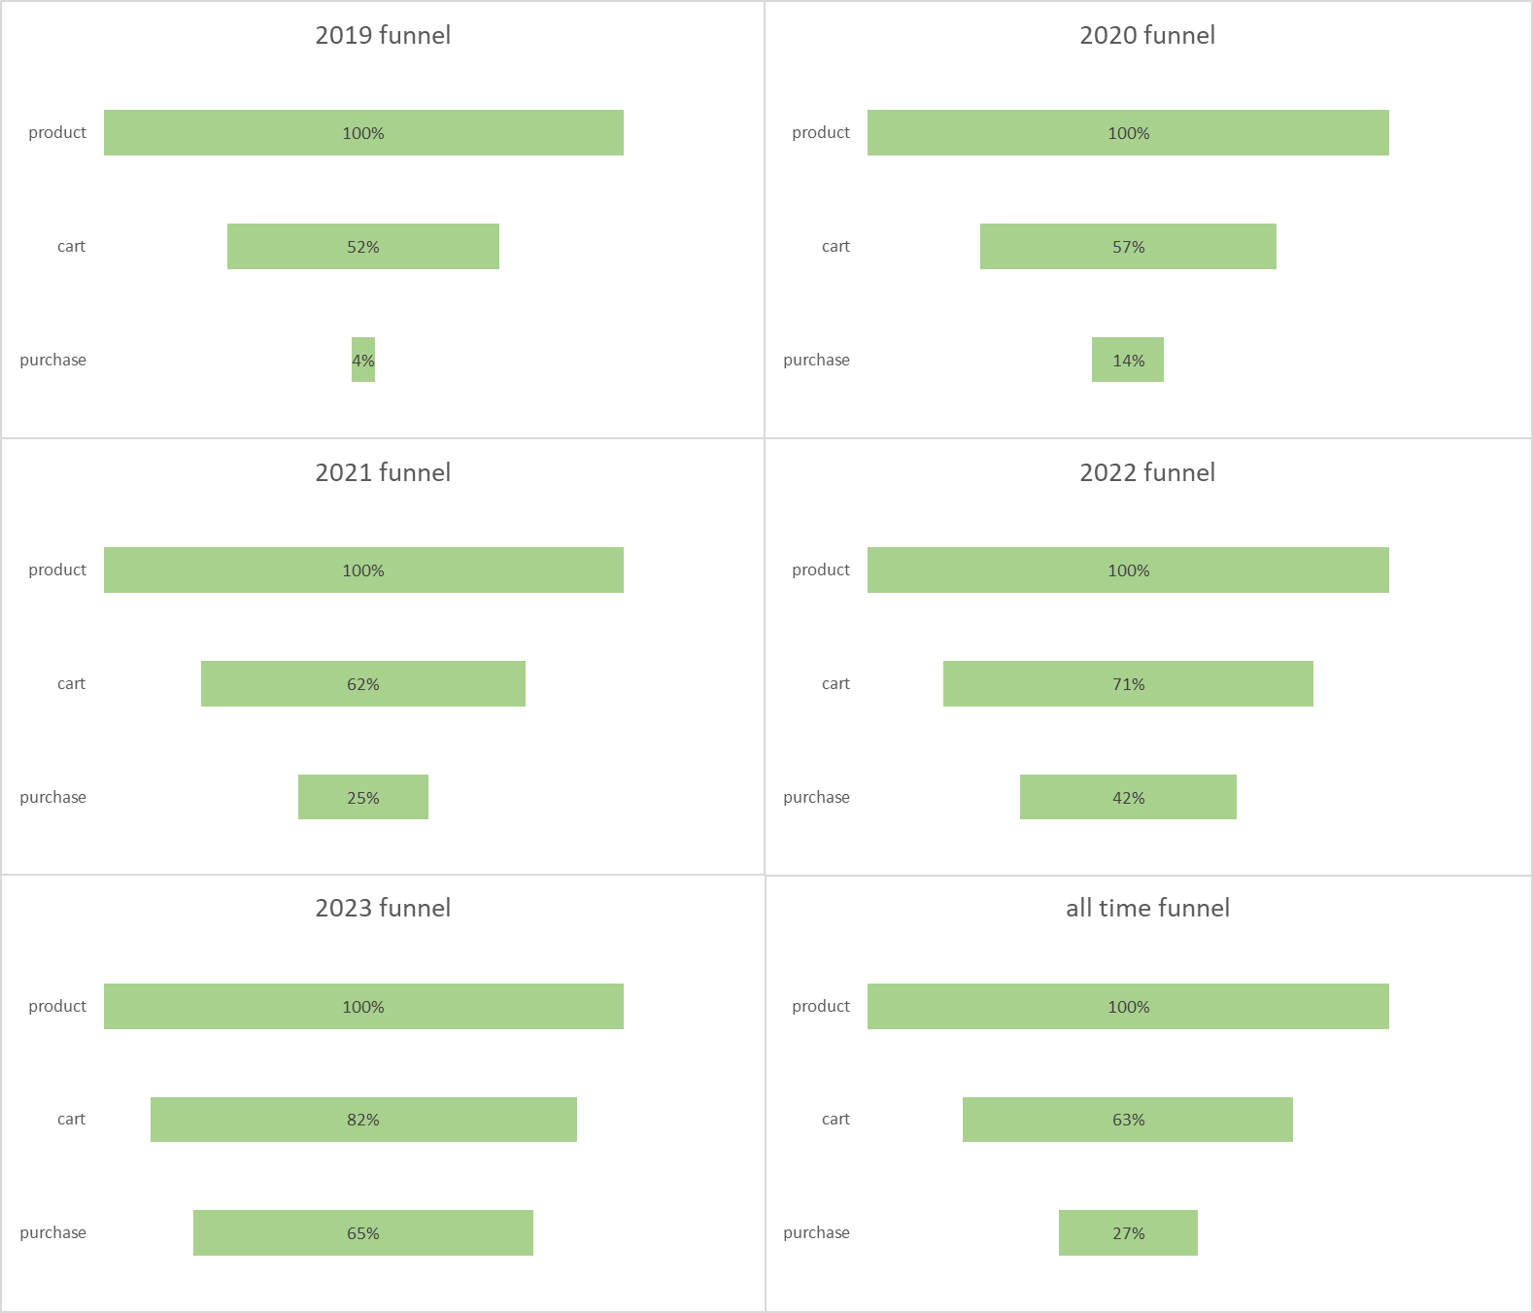

Figure Purchase funnels.

This gradual conversion improvement is seen for the “cart” step too. In 2019 it was 52% and increased yearly to 57 %, 62 %, 71% and 82% for 2020, 2021, 2022 and 2023 respectively.

If we look at the purchase funnel for all time, 63% of users at the “product” step continued to the “cart” and 27 % went to the “purchase” step.

The purchase funnel was also analyzed for different browsers and traffic sources. The results can be seen in tables 4 and 5.

Table Funnel analysis for different browsers.

|  |  |  |  |  |  |
| --- | --- | --- | --- | --- | --- |
| Funnel step | Chrome | Safari | Firefox | IE | Other |
| Product | 100 % | 100 % | 100 % | 100 % | 100 % |
| Cart | 79,6 % | 79,39 % | 79,86 % | **80,92 %** | 79,45 % |
| Purchase | 57,62 % | 57,89 % | **58,27 %** | 58,13 % | 57,16 % |

The biggest percentage of users continue to the “cart” when using Internet explorer (80,92 %) while values for other four categories do not differ much (from 79,39 % to 79,86 %). The highest value for “purchase” is 58,27 % for Firefox, however other four categories do not fall behind by much as “Other” has the lowest percentage at 57,16 %.

Table Funnel analysis for different traffic sources.

|  |  |  |  |  |  |
| --- | --- | --- | --- | --- | --- |
| Funnel step | Email | Adwords | Youtube | Facebook | Organic |
| Product | 100 % | 100 % | 100 % | 100 % | 100 % |
| Cart | **79,9 %** | 79,35 % | 79,47 % | 79,66 % | 79,83 % |
| Purchase | 58,25 % | 57,18 % | 57,27 % | 57,66 % | **58,89 %** |

The highest value for “Cart” is for the email traffic source at 79,9 % while the worst is not that far behind at 79,35 % for Adwords traffic source. When it comes to “Purchase” step we see the highest value for organic users at 58,89 % while the worst is less than two percent lower at 57,18 % for Adwords.

All in all, the purchase funnel seems to be improving through the years. However, it is difficult to find different browsers or traffic sources that greatly outperform the others.

# Conclusion and recommendations

Overall, “theLook” has a solid growth of sales and profit. While it has an above industry average profit margin, it is not growing, which should be looked into more carefully.

When looking at the customer segments, “theLook” has a strong “champion” segment, while “loyal” segment is quite small. This could be improved by converting users to “loyal” from a big “at risk” segment.

Lastly, the purchase funnel for “theLook” is improving through the years. It does not have many differences when comparing different traffic sources or bowsers. The purchase funnel should be reviewed periodically and necessary actions should be taken if the funnel worsens.

1. <https://www.oberlo.com/statistics/us-ecommerce-sales#:~:text=Data%20from%20the%20US%20Department,recording%20a%207.44%25%20annual%20increase.>
2. <https://cogsy.com/blog/good-profit-margin-ecommerce/#:~:text=Ecommerce%20profit%20margin%20FAQs,widely%20considered%20bad%20profit%20margins.>